- Lesson Context
BIG PICTURE of this UNIT: | - How & why do we build NEW knowledge in Mathematics?  - What NEW IDEAS & NEW CONCEPTS can we now explore with specific references to QUADRATIC FUNCTIONS?  - How can we extend our knowledge of FUNCTIONS, given our BASIC understanding of Functions?
CONTEXT of this LESSON: | Where we’ve been  In UNIT 1, you were introduced to & practiced with basic function concepts & applied them to Linear functions | Where we are  WHY & HOW do we transform parent functions, specifically a quadratic function | Where we are heading  How do we extend our knowledge & skills of quadratic functions, given the new ideas & concepts we now know about functions.

- Lesson Objectives
  - Review KEY IDEAS in our parent function, y = x²
  - Investigate the role of the parameter a in the equation y = ax² and relate that role to the concept of TRANSFORMATIONS
  - Apply the idea of transforming a parent function to (i) contextual applications & (ii) further functions

- Fast Five (Skills Review Focus)
Given the quadratic function f(x) = (x – 2)(x – 4):  (a) find the zeroes  (b) find the axis of symmetry  (c) find the vertex  (d) find the y-intercept  (e) write the equation in standard form  (f) Sketch the parabola, labelling key features | Given the triangle defined below:  (a) Translate the triangle 3 units right and 2 units down  (d) Reflect the triangle in the x-axis  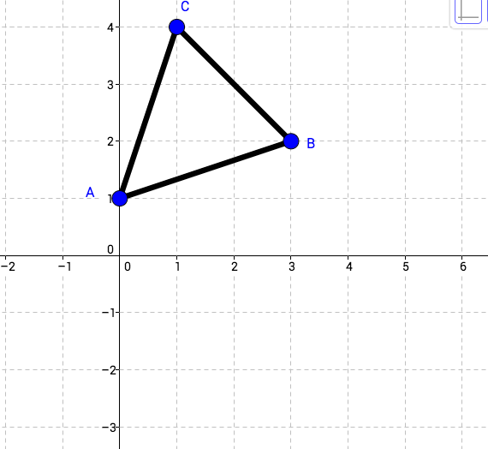

- Observation Table for Exploration

What is the relationship between the value of the parameter a in the equation y = ax² and the shape of the graph of the function. How do we DESCRIBE the change in the appearance of the graph?

1. Enter y = x² into Y1 of the equation editor of your GDC
2. Set your windows (-4.7 < x < 4.7 and then -3.1 < y < 9.3)
3. Enter y = 2x² into Y2 and y = 5x² in Y3 and graph these. What appears to be happening to the SHAPE of the parabola as the value of a increases? | 3.
4. Where would you expect the graph of y = 3x² to appear, relative to the other 3 graphs? Test your conjecture by entering y = 3x² into Y3. Was your conjecture true? | 4.
5. Where would you expect the graphs y = ½x² and y = ¼x² to appear relative to the graph of y = x²? Test your conjecture. | 5.
6. Describe the effect of the parameter a when 0 < a < 1. | 6.
7. Where would you expect the graph of y = ¾x² to appear, relative to the other three graphs? Check your conjecture. | 7.
8. Enter y = -4x² into Y2 and y = -¼x² into Y3 and graph these functions. Describe the effect of a on the parabola when a < 0. | 8.
9. How does changing the value of a in the equation affect the SHAPE of the graph. | 9.
10. REFLECTING: What happens to the x coordinates of all the points on the graph of y = x² when the parameter a is changed in y = ax²? | 10.
11. REFLECTING: What happens to the y coordinates of all the points on the graph of y = x² when the parameter a is changed in y = ax²? | 11.
12. REFLECTING: State the values of a that cause the following TRANSFORMATIONS of y = x²:  (a) vertical stretch  (b) vertical compression  (c) reflection across the x-axis | 12.

- Practicing with Transforming Quadratics

Example 1 (CI): You are given graphs of parabolas in the form of y = ax². PREDICT the equations of each one & give a reason for your prediction. The parent function, y = x², is the thick curve.
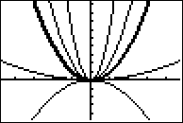 | (a)  (b)  (c)  (d)

Example 2 (CI): Sketch the graph of y = 2.5x² by transforming the graph of y = x². Sketch both graphs, label each graph.  Label the points (1,1) and (-1,1) on the parent function. Then label the corresponding, transformed points (i.e. where do these two original points wind up, AFTER the transformation?) | 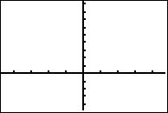

Example 3: Modeling the Golden Gate Bridge ➔ Write an equation that models the Golden Gate bridge, given the superimposed grid on a side profile of the bridge
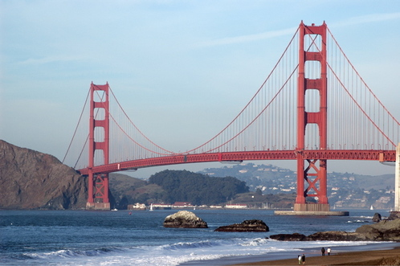
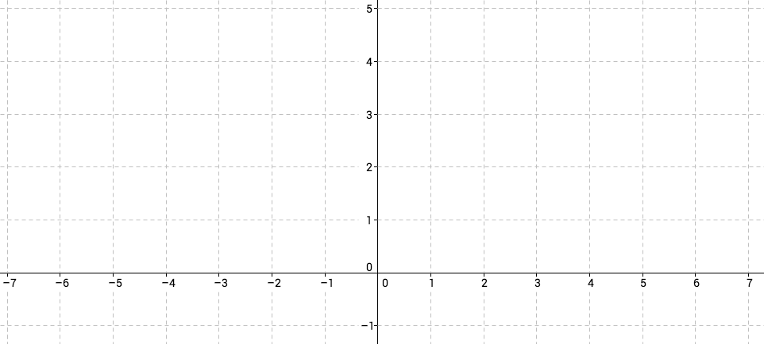

Example 3b: Here are the measurements of the bridge. Rewrite your equation, using the real data.
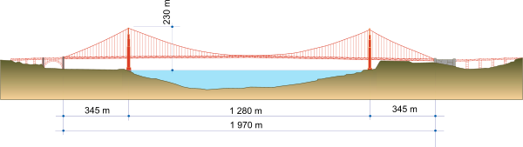

- Extending the Concepts
Example 4: Working with a Piecewise defined function. A function, y = f(x) is illustrated on the grid.  You are required to produce a graph of a new function, called g(x), which is a TRANSFORMATION of f(x) as defined below:  (a) g(x) = 2f(x)  (b) g(x) = -3f(x)  (c) g(x) = -½f(x)  In each sketch, label KEY points very clearly. | 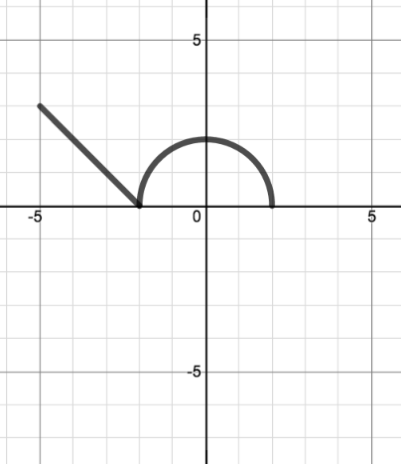
Example 5: Now let f(x) be one of our new parent functions, f(x) = √x. On the grid provided, sketch:  (a) the parent function, clearly labelling the key points (0,0) and (4,2) and (9,3)  (b) y = -3√x, clearly labelling the new locations for the original key points  (c) g(x) = ¼f(x), clearly labelling the new locations for the original key points | 