- Lesson Context
BIG PICTURE of this UNIT: | - How do we analyze and then make conclusions from a data set? (Math)  - How do I present my data and the outcomes of my analysis? (Math)  - How do I use data & statistics to make decisions?  - How do I decide on the validity/reliability of my data? Of my analysis? Of my conclusions? Of my decision?
CONTEXT of this LESSON: | Where we’ve been  Using data & visual representations, present your current understandings of what Statistics is | Where we are  How do we visually represent data? | Where we are heading  How do I analyze and make conclusions from a data set, in whatever way this data gets presented?

- Lesson Objectives:

  - Describe data as either being qualitative (categorical) or quantitative (numerical)
  - Introduce the idea that quantitative data can be either discrete or continuous
  - Introduce different ways to organize & visually represent data ➔ using dot plots, stem & leaf plots, frequency tables, grouped data, histograms/column graphs

- Describing Data (go online to find definitions/clarifications/examples for these terms)

  - Qualitative Data ➔

  - Quantitative Data ➔

    - Discrete quantitative data ➔

    - Continuous quantitative data ➔

- Activity #1 – Organizing and Representing Data
Mr Santowski has two athletes competing in a 400m sprint and he needs to collect data in order to help the coaching staff decide which sprinter is the better of the two. Over the course of the training season, the two sprinters have had numerous time trial data collected and the results are listed below
Sprinter #1 | 57.54 | 55.23 | 59.32 | 58.42 | 58.21 | 56.37 | 57.41 | 56.10
 | 53.11 | 55.42 | 57.31 | 58.46 | 57.19 | 55.16 | 54.12 | 56.25
 | 54.26 | 55.71 | 54.70 | 53.89 | 56.25 | 54.68 | 53.19 | 53.82
 | 57.29 | 55.54 | 54.96 | 53.87 | 55.21 | 53.32 | 54.10 | 53.61
 | 55.49 | 53.15 | 54.64 | 55.91 | 57.80 | 54.48 | 53.93 | 55.12
 | 57.91 | 58.13 | 52.95 | 52.62 | 53.10 | 54.54 | 58.04 | 56.81

Sprinter #2 | 57.67 | 56.29 | 58.01 | 54.28 | 54.63 | 57.95 | 56.21 | 55.04
 | 55.45 | 57.96 | 53.82 | 57.31 | 56.19 | 54.67 | 56.91 | 53.43
 | 55.17 | 54.44 | 56.28 | 57.34 | 54.99 | 57.22 | 56.23 | 56.31
 | 53.52 | 55.20 | 54.83 | 54.96 | 57.03 | 54.05 | 54.27 | 53.61
 | 55.26 | 57.36 | 57.38 | 54.93 | 53.82 | 53.01 | 54.82 | 56.67
 | 55.93 | 57.21 | 57.58 | 56.91 | 55.33 | 58.11 | 54.96 | 54.60

To help with the data analysis from each experiment, your group will:
        - Prepare a Stem and Leaf plot for each data set. (Here are three links showing you how to prepare a stem and leaf plot) ➔ Link #1 from Math is Fun; Link #2 from PurpleMath and Link #3 from our Haese and Harris reference text on page 113.
SPRINTER #1 |  | SPRINTER #2
Stem | Leaf | Stem | Leaf

        - Prepare a Frequency table for each data set. (Here are two links showing you how to prepare a frequency table) ➔ Link #1 from MathsTeacher.com and Link #2 from our Haese and Harris reference text on page 113
SPRINTER #1 |  |  | SPRINTER #2
Interval | Tally | Frequency | Interval | Tally | Frequency

        - Prepare a Column graph by hand for each data set. (Here are three links showing you how to prepare a frequency histogram from a frequency table) ➔ Link #1 from Math is Fun; Link #2 from Open High School Courses; and Link #3 from our Haese and Harris reference text on page 114.
SPRINTER #1 | SPRINTER #2


        - Now you need to make a decision ➔ who’s the BEST and why?

        - Now you have an opportunity to ASK QUESTIONS about the data, about the data collection, about the conditions, etc

        - Prepare a Column graph on your graphing calculator for each data set (instructions linked here.)

- Exercises
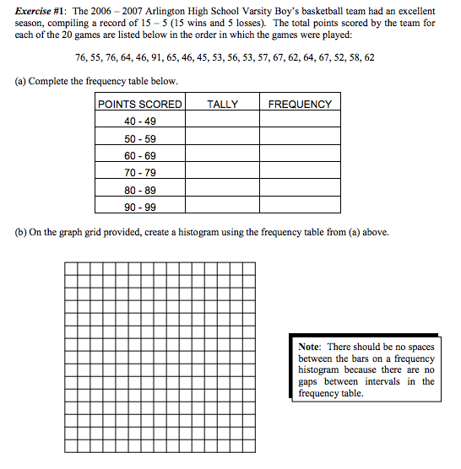
- Exercise #2
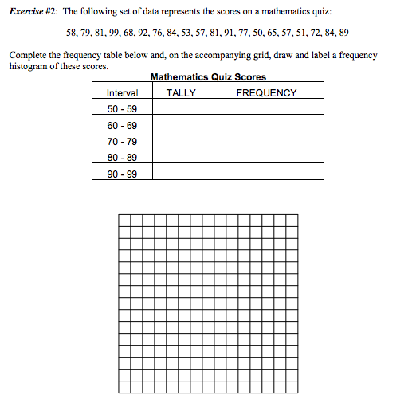

- Exercise #3
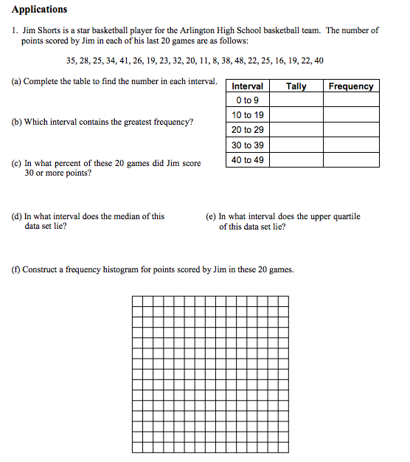
- Homework
- From Haese & Harris Mathematics Textbook ➔ Complete Exercise 5A, p 111, Q1 & 2.
- From Haese & Harris Mathematics Textbook ➔ Complete Exercise 5B, p 116-7, Q1 – 6.

